**Hospital Appointment No Show predication**

by Nouf Salamn Almutairi

The idea of this project is to implement a model that can predict if the patient will attend the appointment or not. The source of the data is from kaggle Date source link: [https://www.kaggle.com/joniarroba/noshowappointments](https://www.kaggle.com/joniarroba/noshowappointments" \t "_blank)

**Data Description**

* The dataset that will be used in this project is a patient appointment data with the status of the patient as show or no show
* The source of the data is from kaggle**.**
* The data consist of 110,527 records with 13 features.

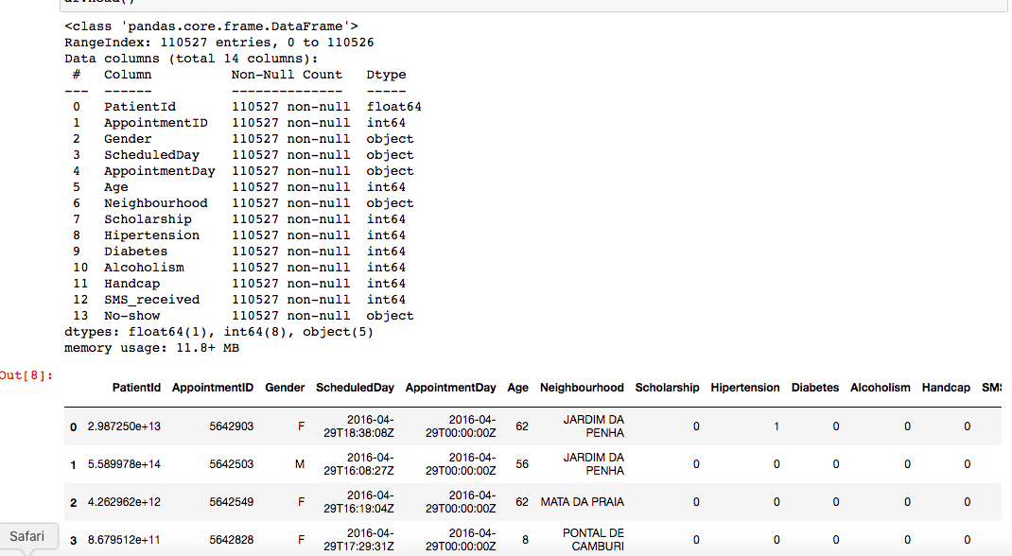

**Visualization**

* No Show Weekday

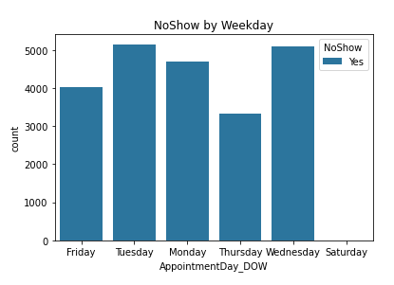

* Probability to show\ No Show with the age

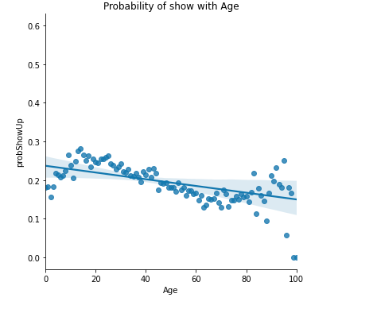

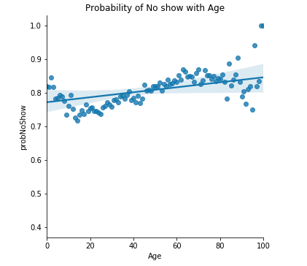

Clearly form the graphs that the weekday is not good predictors of Status, since there is no significant figure between the no-show cases and the weekday of the appointment. However the probability graphs show that there is dependency between patient age and appointment status as show\No show.